# Lesson 3: Choosing and Characterizing Metrics

## Introduction

Metrics for Experiments

* Define
* Build Intuition
* Characterize

## Metric Definition Overview

Invariant checking

* Population is same
* Users same across the two groups
* Distributions same across different buckets

Business Metrics

* Revenue

More detailed metrics

* How long a user stay on a page?

Type of metrics

* Sanity checking metrics
* Evaluation metrics
  1. Business metrics
  2. Detailed metrics

For sanity checking you might need multiple metrics.

Steps

1. Come up with high level concept for a metric
   1. Active Users
   2. Click-thru probability
2. Find out nitty-gritty details like
   1. How do you define what active is? – Is it 7 day or 28 day?
3. Summarize all the measurements into a single metric
   1. Sum, count, average, median

Evaluation metrics

* It depends, some compaies prefer one metric, while other prefer having bunch of metrics
* You might want to however, settle on a single overall objective that you have for the company
* If you have multiple metrics, you can create a composite metric. This can be called as an objective function or OEC (overall evaluation criterion).
* OEC is used by Microsoft and it essentially is a weighted function that combines all of these different metrics.
* It might be tricky to align everybody on this combination of metrics combining revenue, users etc.
* Last thing you look at is how applicable the metric is.

Overall evaluation criterion

This paper discusses the OEC, or overall evaluation criterion, in more detail.

<http://www.exp-platform.com/Pages/hippo_long.aspx>

## High Level Metrics: Customer Funnel

Business Objective

* Helping students get jobs
* Financial sustainability

We can break the above objectives down into steps using a customer funnel.



* How many users visits the homepage
* How many users explore the site
* How many users created the account
* How many users complete the course

The idea is each of these is a step in the process of either getting a job or helping Audacity making money.

There could be more stages in this funnel that a user might go through-



* We have fewer and fewer users that get to each stage of the funnel.
* Actual timeline of a particular users is more like a swirl
  1. Example- users might complete a course without accessing coaching
  2. Student who hasn’t completed a course might enrol into a new course
* It’s also important to consider how this funnel would look across different platforms
  1. Sometime iphone and android apps have slightly different flow both from each other and the desktop
* You should also be able to track progress through the funnel across platforms
  1. Example- You might see the user start the class on thrir phone, then continue on their laptop.
* Each stage in the funnel right now is a metric that you could use for an experiment, the number of users who reach that point in the funnel.
  1. This is a count
  2. You can also use rate or probability
  3. The reason to use a rate is because you want to first figure out how many people enter the funnel. Ans then increase the rate at which people progress down the funnel.
  4. For each rate in the funnel, you might also care about the probability that a unique user progresses down the funnel.

## Choosing Metrics

* Choose the best primary metric to evaluate the experiment on Audacity

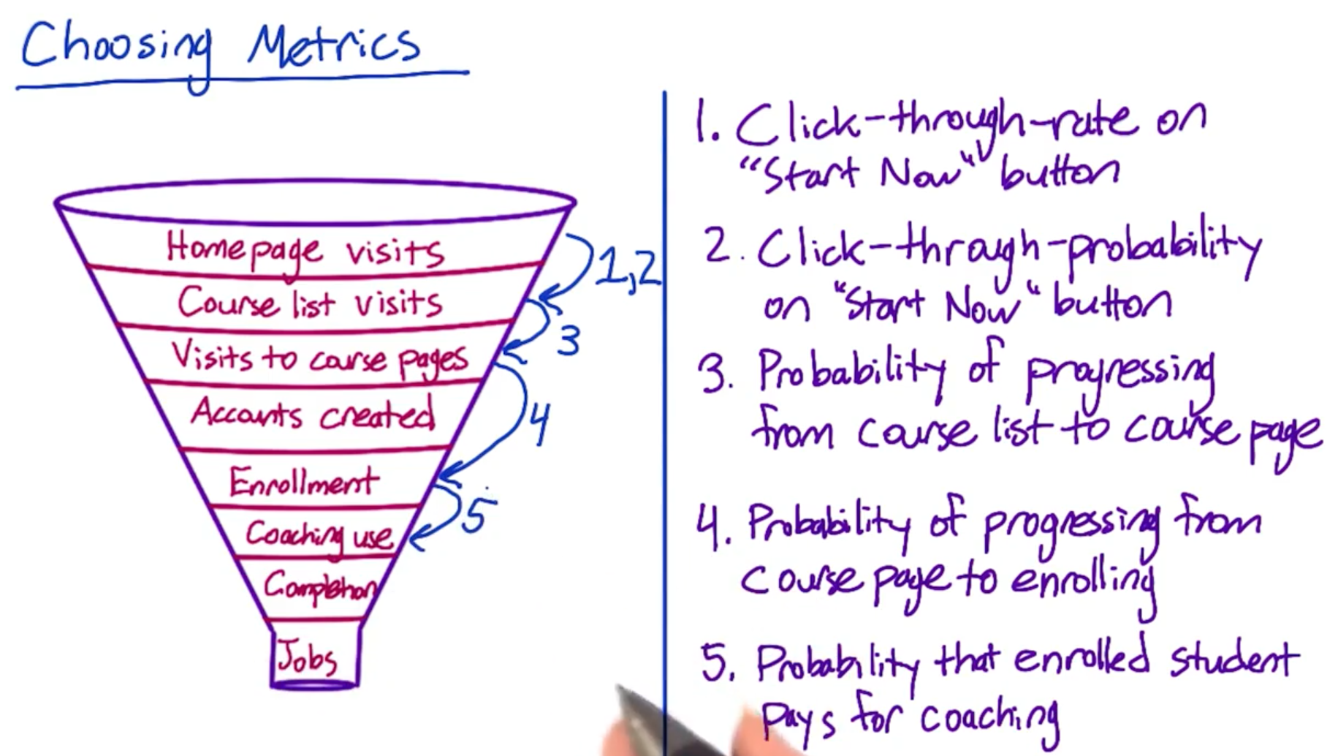

Choose the best primary metrics from the option that should be use to evaluate the following 3 experiments. Also discuss what additional metrics you would want to track for each experiment (red).

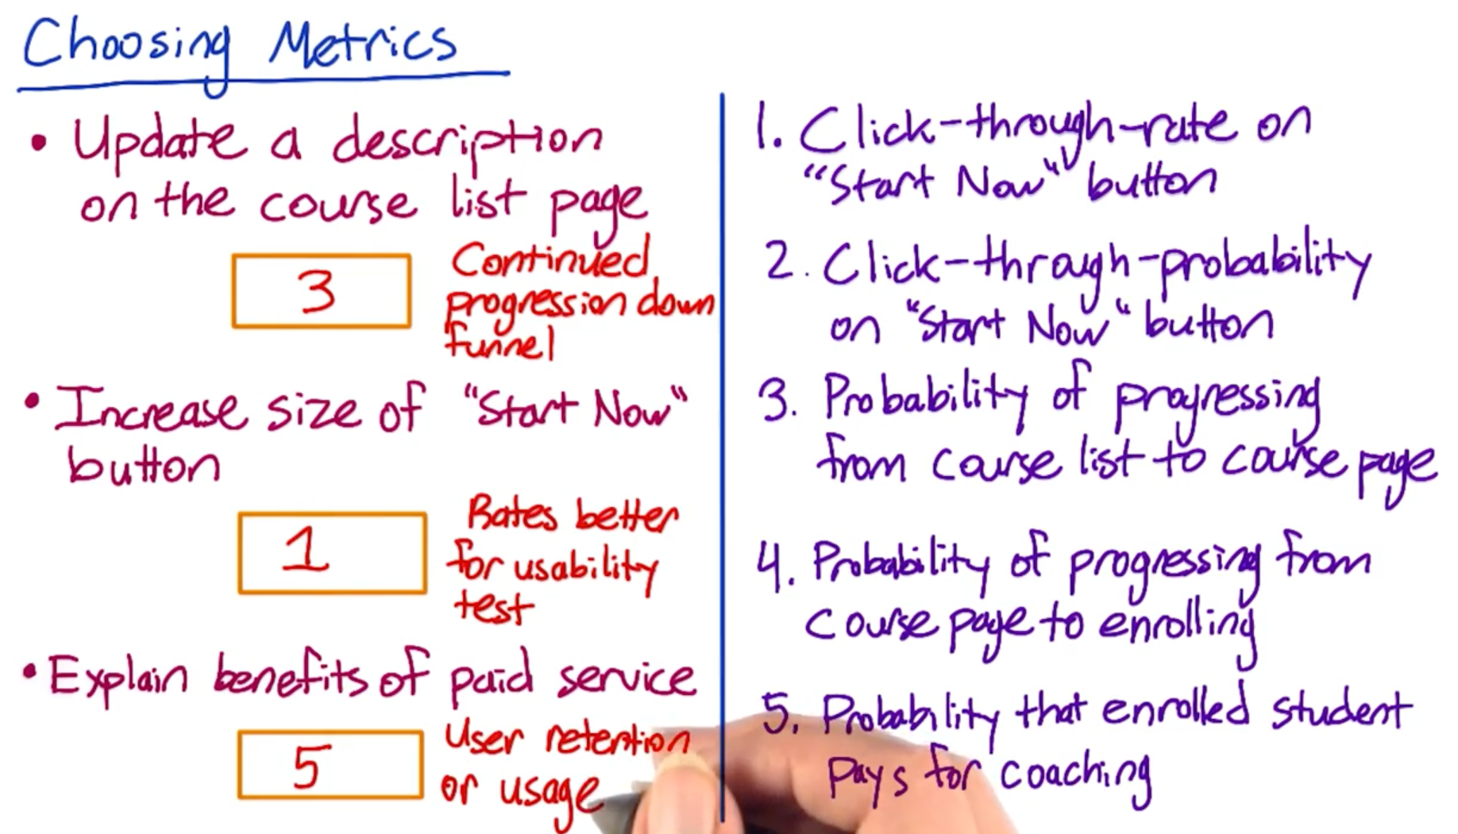

## Difficult Metrics

* Often in AB testing, you will find that a metric you want is difficult to measure.
* This could happen because
  1. You don’t have access to data
  2. Metric takes too long to collect
* Example- in the Audacity example, the last level of the funnel was how many students get jobs.
* Audacity probably does not know when one of it’s students get a job. And even it did, getting a job can be a long process. So, both the above scenarios are applied in here. Hence, it might not be possible to use this as a metric for most experiments

Quiz- Check if a metric would be difficult to measure for either of the two reasons-

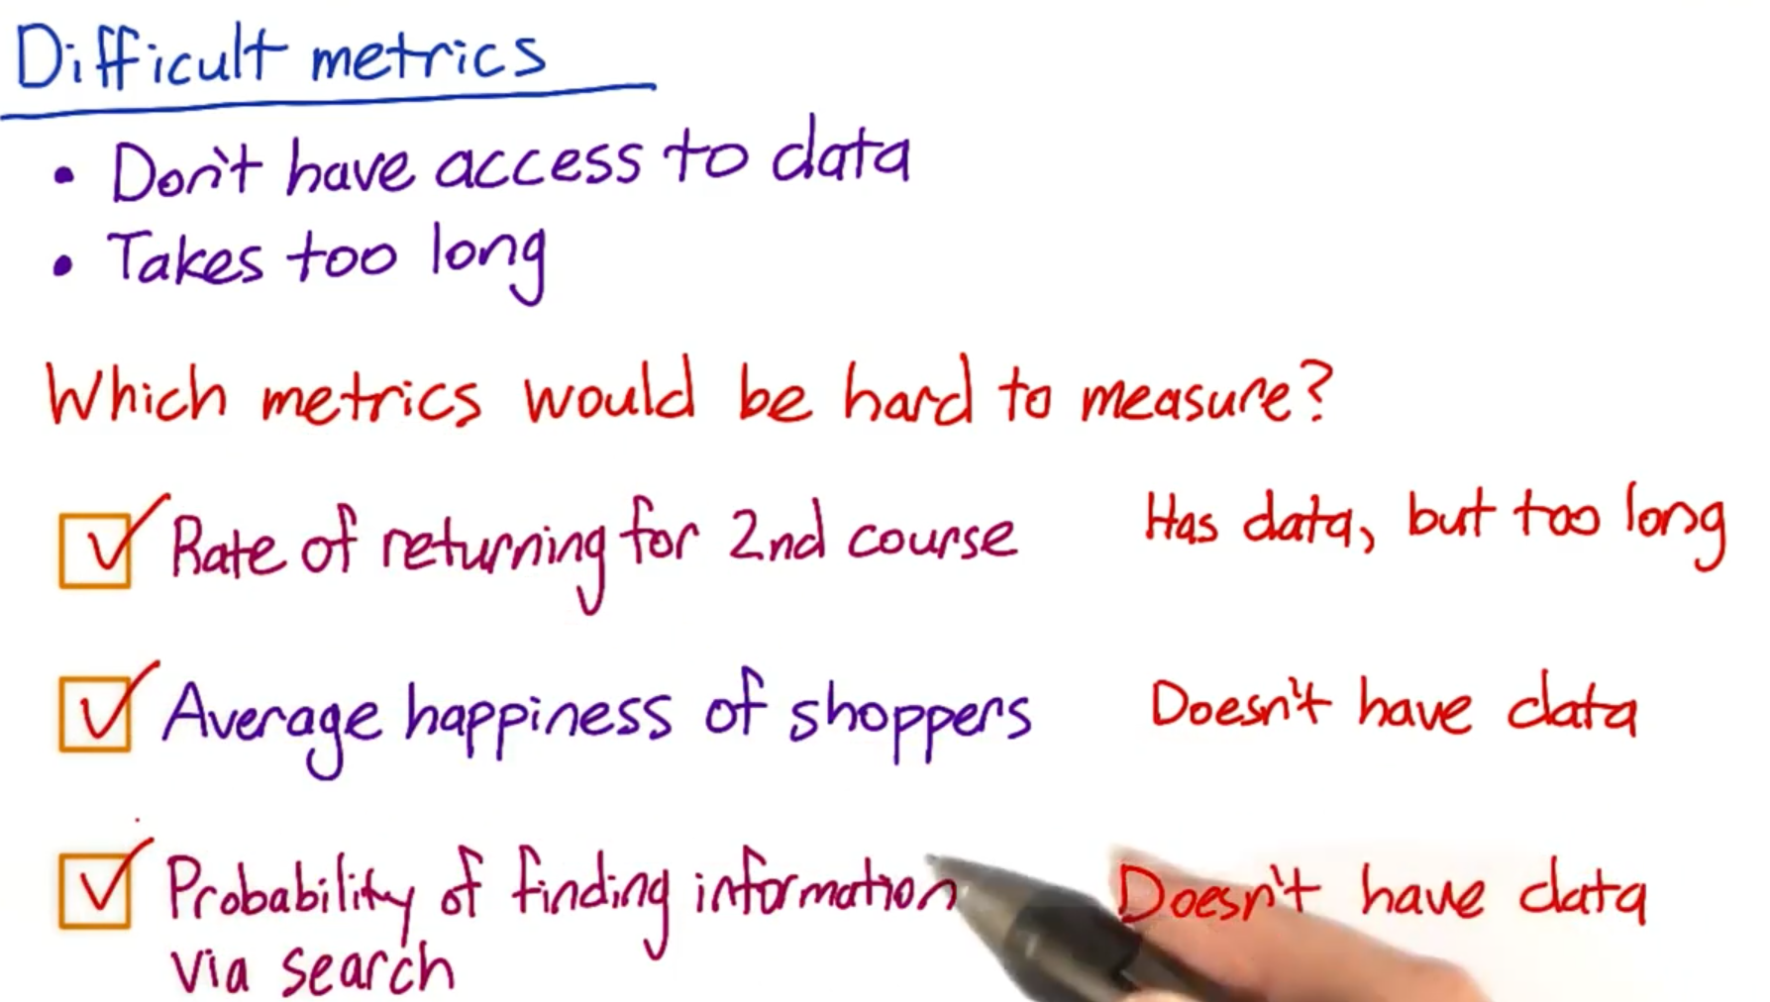

Additional Techniques for Brainstorming and Validating Metrics Supporting Materials

PDF: <https://s3-us-west-2.amazonaws.com/gae-supplemental-media/additional-techniquespdf/additional_techniques.pdf>

## Difficult Metrics: Other techniques

* Since some metrics are difficult to measure directly, there are some other techniques that can be used.
* These techniques are also useful in generating new ideas for metrics as well.
* There a lot of such techniques, ranging from surveys to retrospective analyses to focus groups.
* These techniques can be used for both brainstorming new metrics, as well as validating possible metrics.
* Here we will dicuss only briefly, for the details, check the below PDF.
* You get these types of data from a source of your company.
  1. External data
* One type of company that can collect external data at granular level is about the market share vertical such as how many people are interested in travel industry and even for specific websites, they may have visitor data that they put together. Example- companies like comScore, Nielsen use different techniques.
* Second type of companies that might be useful are the ones who run surveys of users. These are companies such as a Pew or Forrester. They may ask users how many different devices you have? How much time you spend on them in a given day?
* Third category is academic research. These are papers that try to establish metrics, they may run correlation studies. You may be able to find data that you need or very similar data.
* These sources are great for brainstorming as well as to think of new metrics ideas. They are also good validating metrics.
  + - Example- I get these many visitors per day, but when I look at the industry standard, it looks completely whack.
    - They can also help you develop validation metrics.

Additional Techniques for Brainstorming and Validating Metrics

<https://s3-us-west-2.amazonaws.com/gae-supplemental-media/additional-techniquespdf/additional_techniques.pdf>

## Other techniques: Part-2

* 1. Internal Data
* Two classes of methods
  1. One uses all the existing data
     + Example- if you are running experiments, you probably have existing logs or data capture that you’re using to measure metrics and sort of track your business.
     + So, there would be set of techniques, that would be using this type of existing data, both retrospective analyses, as well as running experiments.
  2. Other class of methos are when you want to gather new data
     + Use this when you cannot answer questions from your existing data
     + Main techniques are – User experience group, Surveys and focus groups

What can you do with your own external logging data or data captured from your website?

* Retrospective observational analysis
  + - Metric you are interested in or the measurements you take from your site or change in responses to changes you have made in the past, experiments you have run, big spikes in your business
    - This is good to get your baseline and can help develop theories
    - This data can also be used in conjunction with other methods such as surveys or user experience research
    - The problem with these studies is they show you correlation, and not necessarily causation
    - Since you are not here running a parallel A vs B, or A vs B vs C vs D experiment, it’s really hard to establish that the change you made actually CAUSED what happened and that it’s not some temporal effect.
    - This is the difference between doing this type of analysis and doing a real structured experiment.
    - So, using retrospective observational analysis is best for establishing a correlation and not a causation.

## Techniques to gather additional data

There are three common techniques to gather additional data about your users-

* These techniques are usually compared on two major axis
  1. Depth of data that can be collected
  2. Number of participants

* User Experience Research (UER)
  + - Here, you can go really deep with just few users, often by observing them doing tasks of interest
    - Good for Brainstorming
    - Can you special equipment
    - You might want to validate the results using something like retrospective analysis
* Focus Groups
  + - You bring in more-users here. So, you can talk to more total users than with a UER study
    - You can’t go deep to each user here
    - Can get feedback on hypothesis
    - You might run the risk of group think, where few users might dominate
* Surveys
  + - Surveys are pretty cheap to run on a whole bunch of users
    - The data is more quantitative, but not very deep or individually customized
    - Useful for metrics you cannot directly measure
    - You cannot directly compare to other results

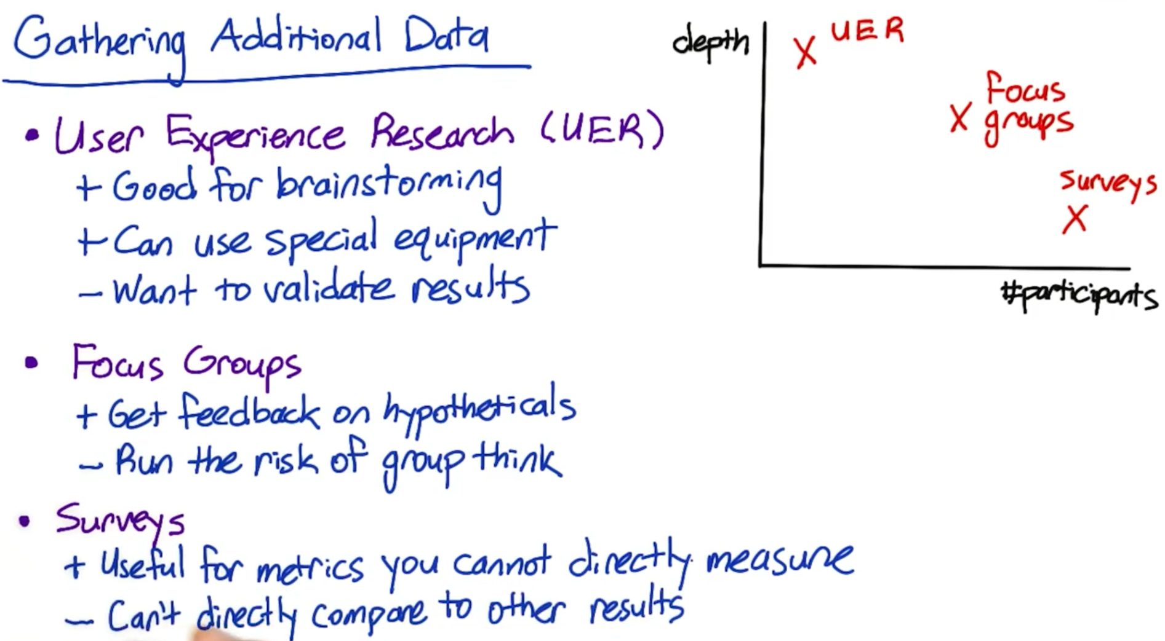

## Other techniques: Example

Looking at how the above three methods can be applied to Audacity example-

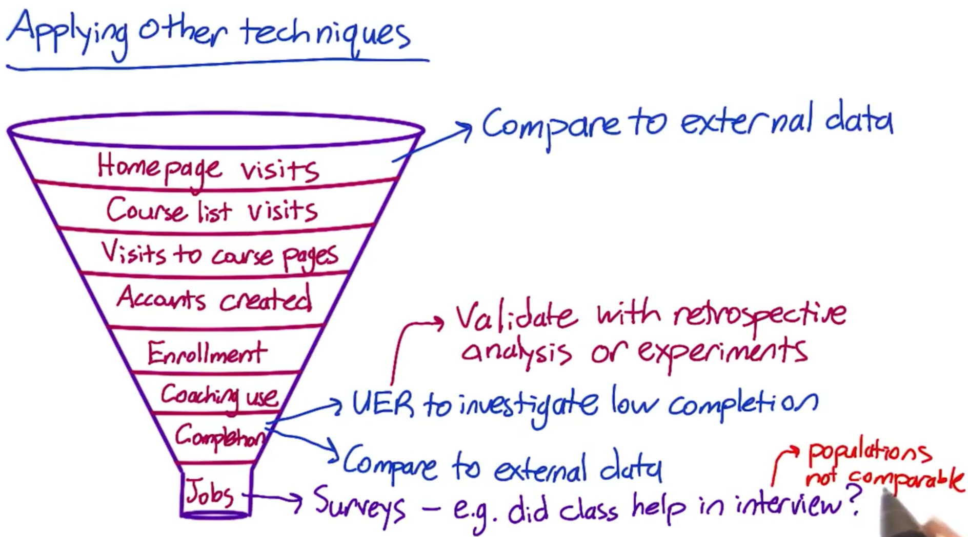

Examples to apply other techniques to difficult to measure metrics –

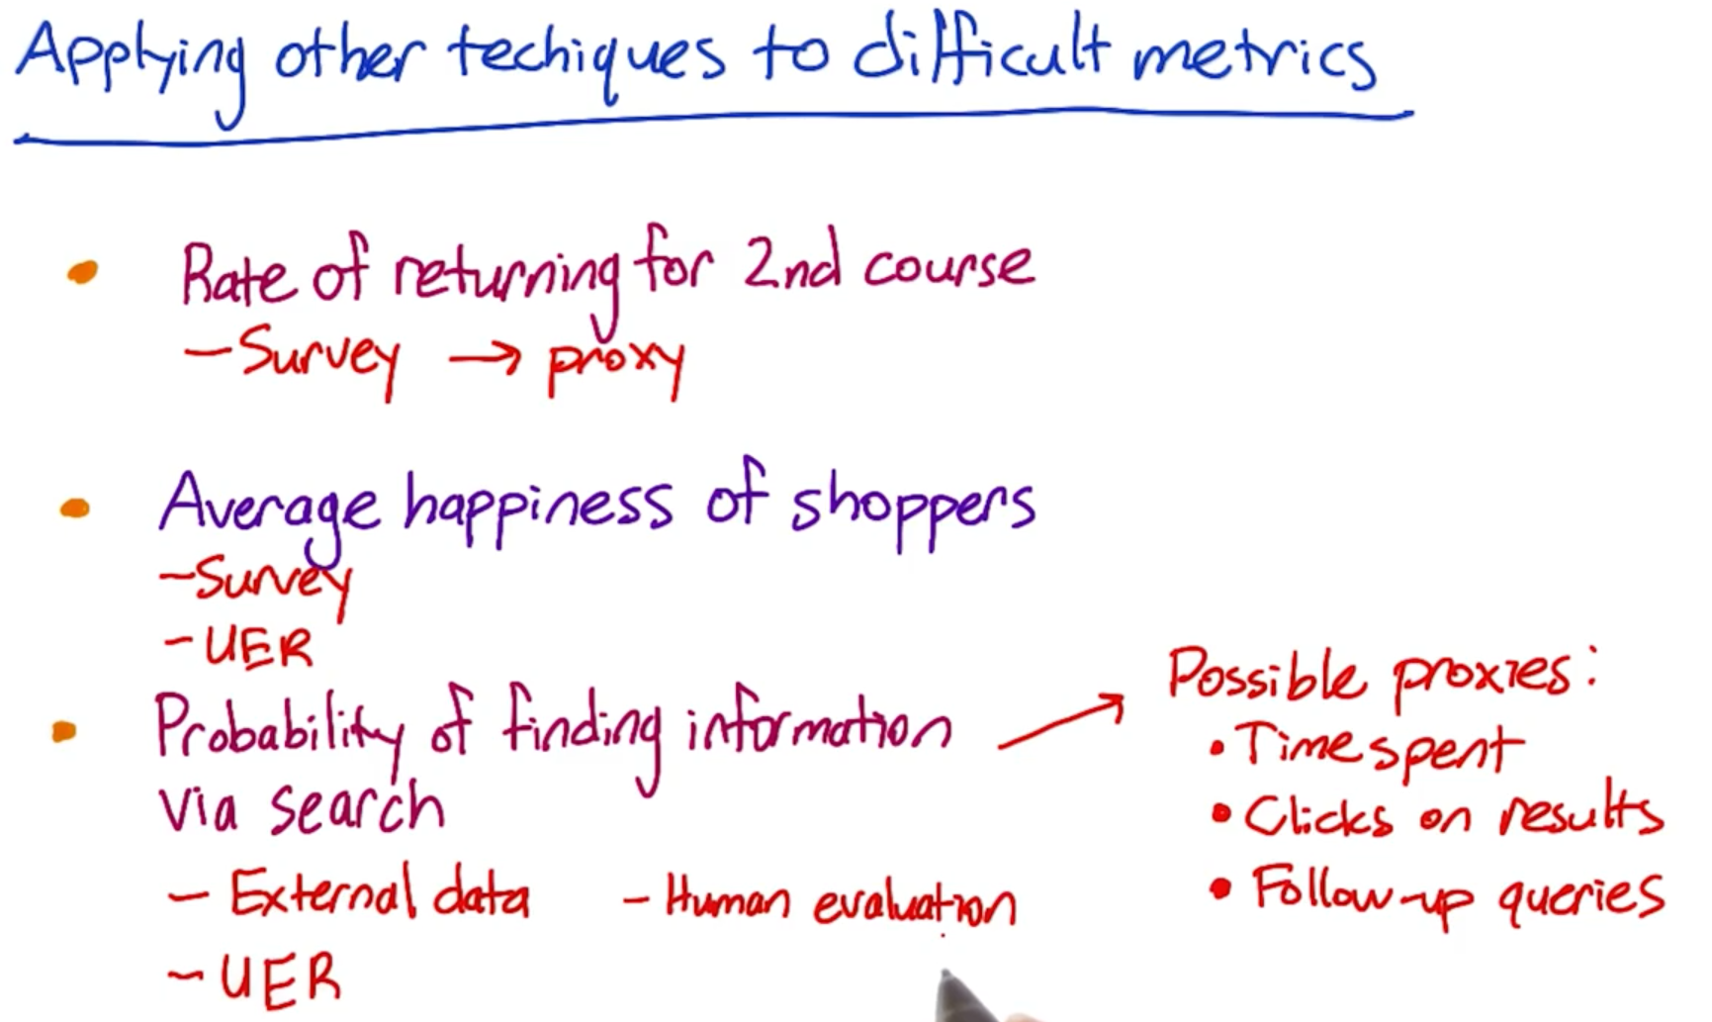

### Quiz

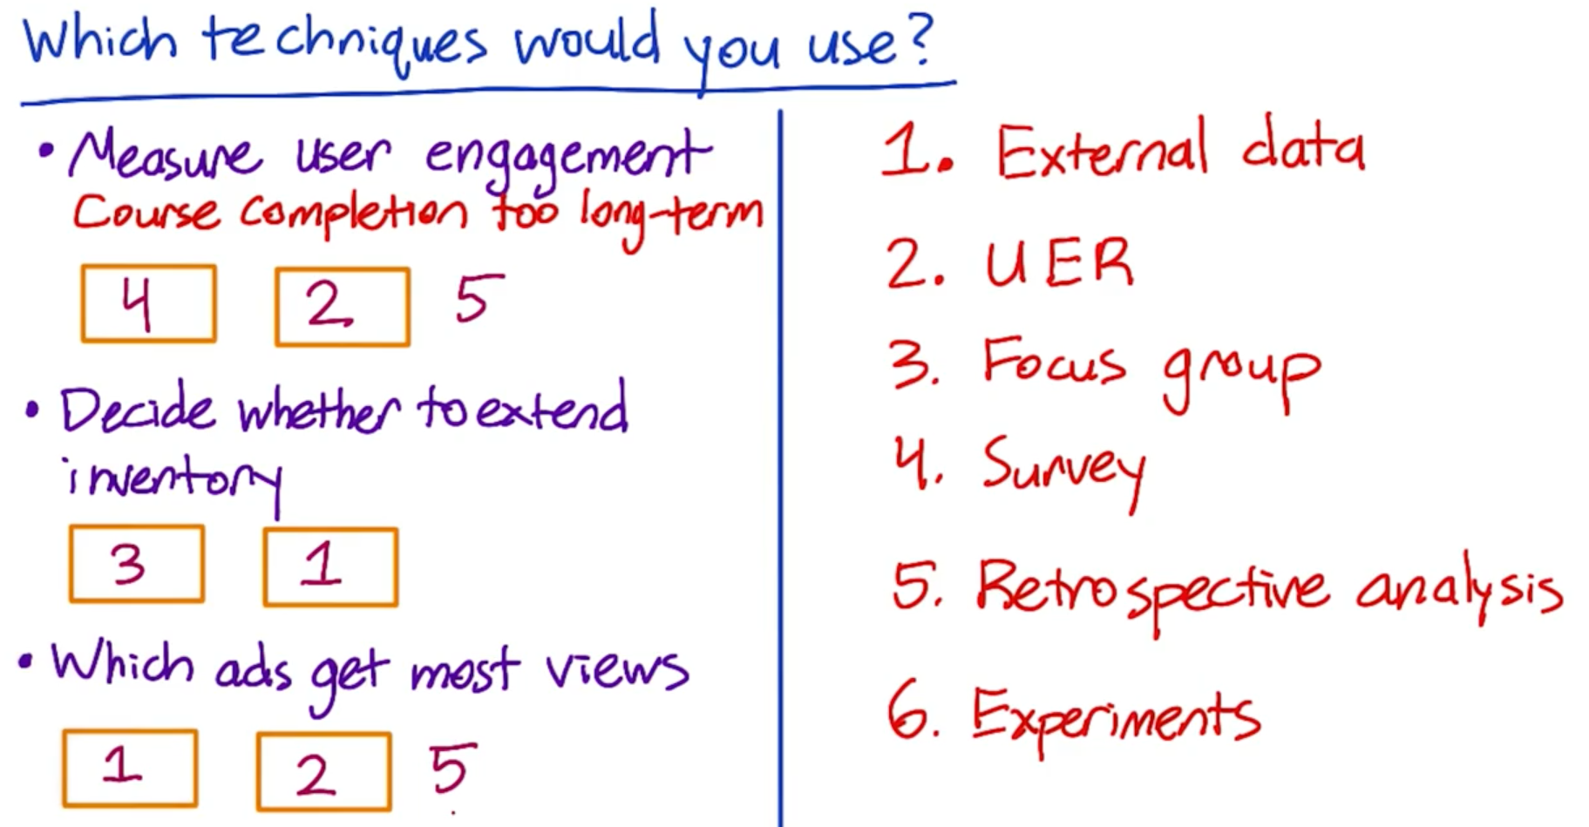

## Metric definition and data capture

Issues in computing these techniques-

Two steps to define fully defined metrics

* Fully define exactly what data we’re going to look at to actually compute the metric
  + - Example- Which events do I count in my numerator or denominator
* Given those events, how do I summarize my metrics?
  + - Compute average, median

The mark of a really good data analyst is whether or not you understand what changes in your data and in your metrics, your system can or cannot produce.

Example- There are multiple ways of calculating click-through-probability

* Total number of clicks to the total number of page views
* Cookie data to see if cookie visited and it they clicked or not

Other things you have to look at –

* Plot your data over the course of a day
* Look at evening
* Weekday effects
* May be the minute or the hour

There could be different nuances and you might want to ask these questions-

Example- If someone arrives at 11:50 pm and click at 12:01 am, do you count this as being part of first days data, or 2nd day’s data.

Example2- Technology for capturing the effects. JavaScript works differently for old browsers, or in Safari and new browsers. You might see different click through rate because of the underlying technologies behind these browsers.

## Metric Definition Example

Example of turning a high level metric into a well defined one-

High level metric – Click through rate



To calculate number of users, you might use cookies.

* Cookie that comes back a week or two later, do we really want to count that once?
  + - Usually those are counted separately
    - This means you also need to choose a time period
* So, do you only count one page view per user each minute, hour, day or what?
* For example using minute-



Generalizing the time interval-



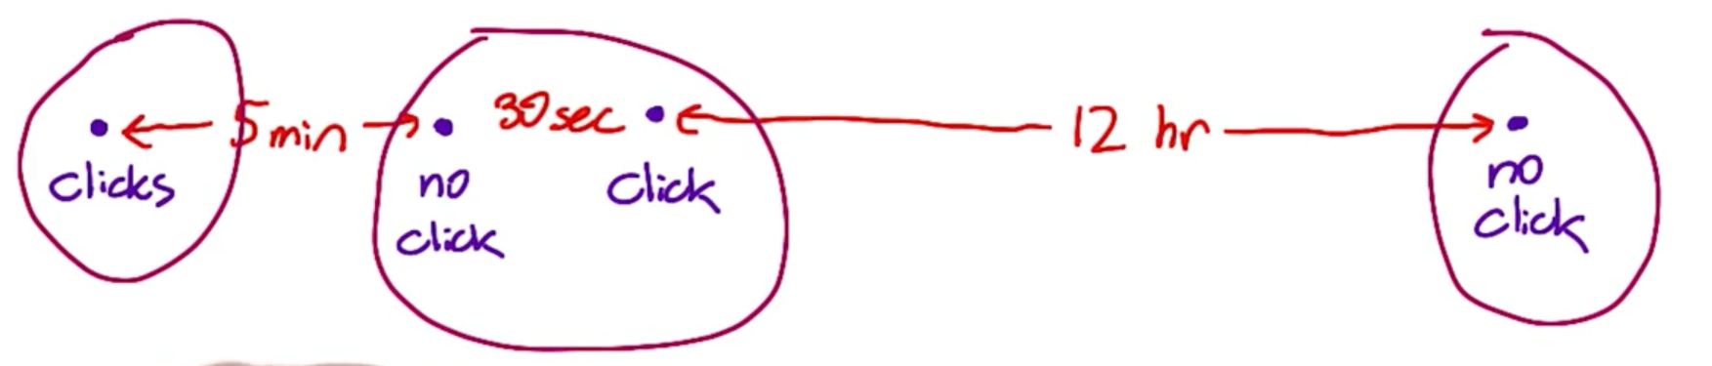

Grouping by different time spent will have different click through probability –

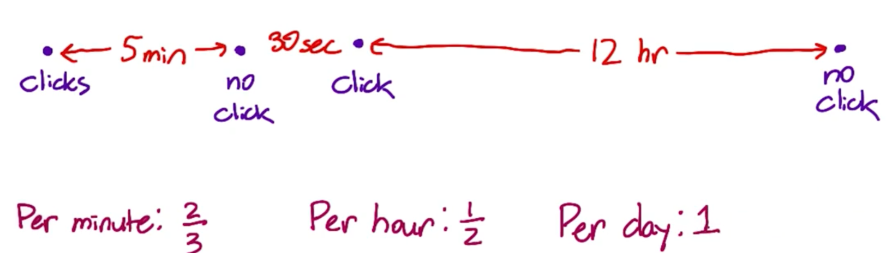



Definition 1 and 2 can yield different probabilities when time interval is not too short.



Metric definitions

* Def #1 (Cookie probability): For each <time interval>, number of cookies that click divided by number of cookies
* Def #2 (Pageview probability): Number of pageviews with a click within <time interval> divided by number of pageviews
* Def #3 (Rate): Number of clicks divided by number of pageviews

Which metrics would have the same value regardless of whether problems such as the mentioned occurred?

* Check the mark that would give same value regardless of whether the problem occurred assuming all the events occurred within the time interval.

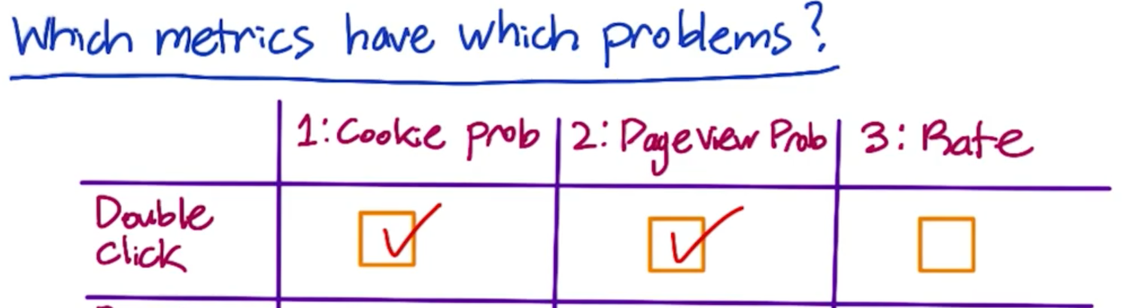







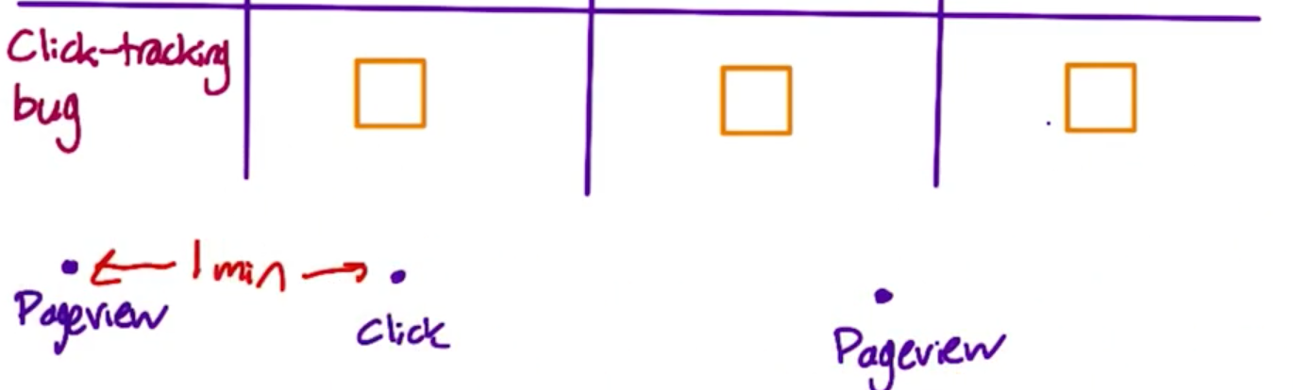

In third case, all the metrics will be affected.

## Filtering and Segmenting

The goal of filtering is to de-bias your data.

* Filter out spam data or traffic that is temporarily visiting the website for checking the experiment
* Internal factor could be- that change only affects subset of your traffic.
* Hence, filtering is useful here as this might otherwise dilute your results.
* Filtering only relevant traffic will also increase the power and sensitivity of your experiment
* Looking over day over day or week over week traffic pattern changes is a good way to spot something that looks at least a little unusual.
* You have to know what changes are expected versus unexpected, so you can determine when you see data for your experiment and ask if you have a problem? Or if you believe this?

## Filtering and Segmenting Example

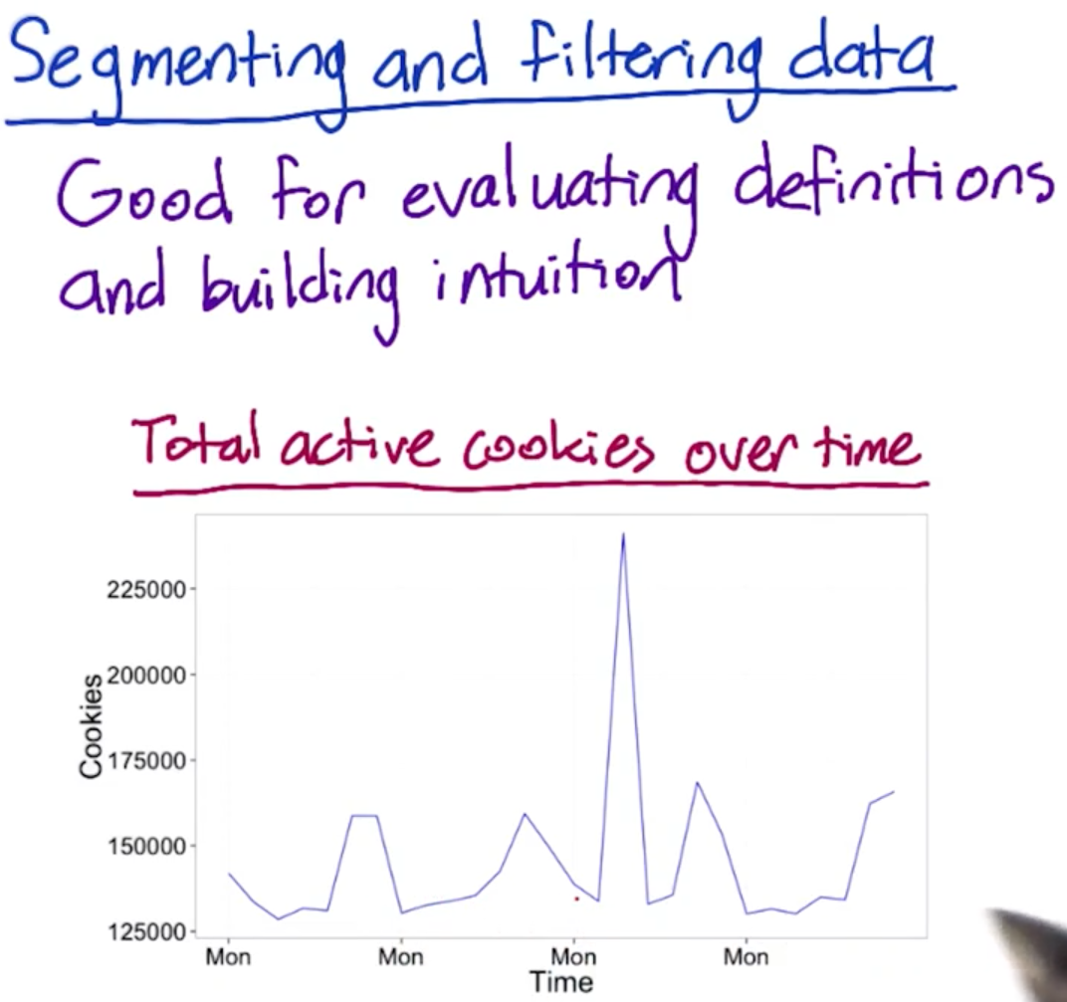

* We see there is a weekly spike. Additionally, there is a high spike that look unusual. To verify that, we should plot week-over-week plot to see if there is any variation.

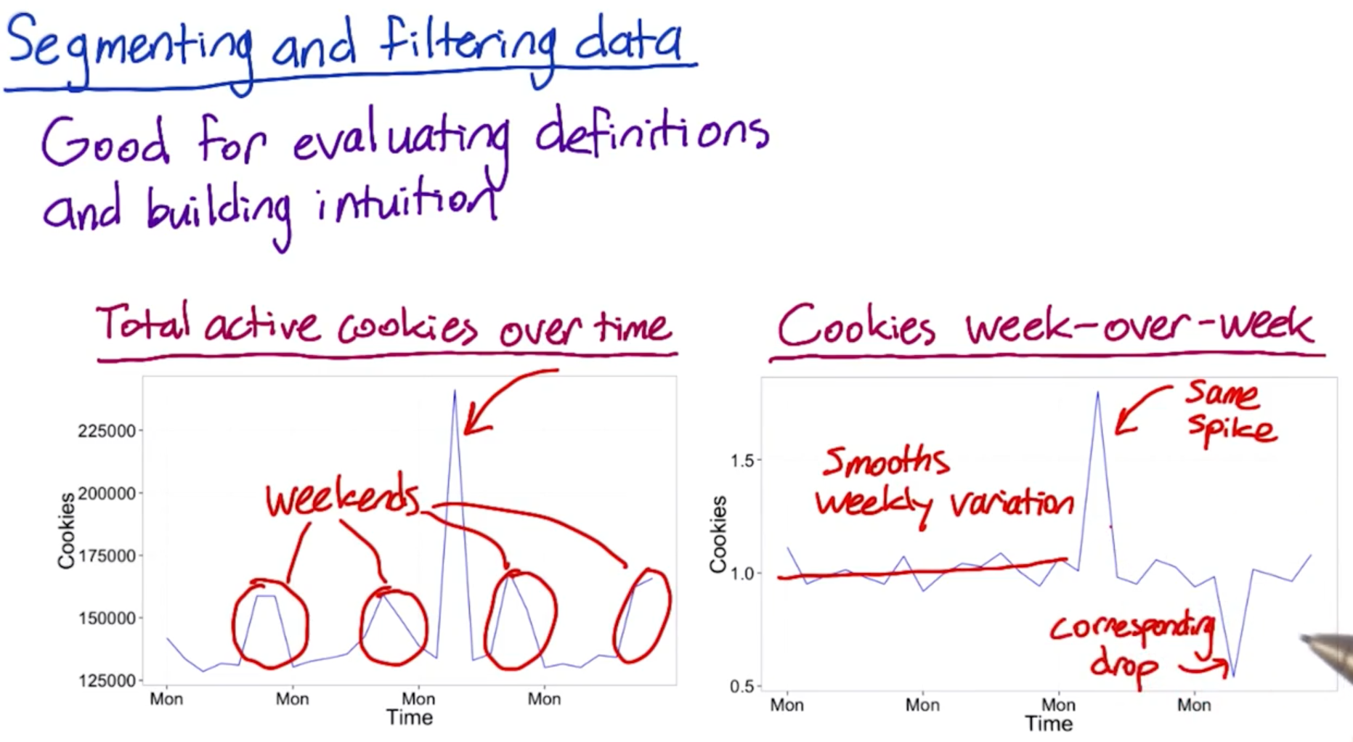

* Week-over-week plot smooths out the variation, but that unusual spike still holds.
* Another thing is to look at year-over-year variations or variations by country.
* 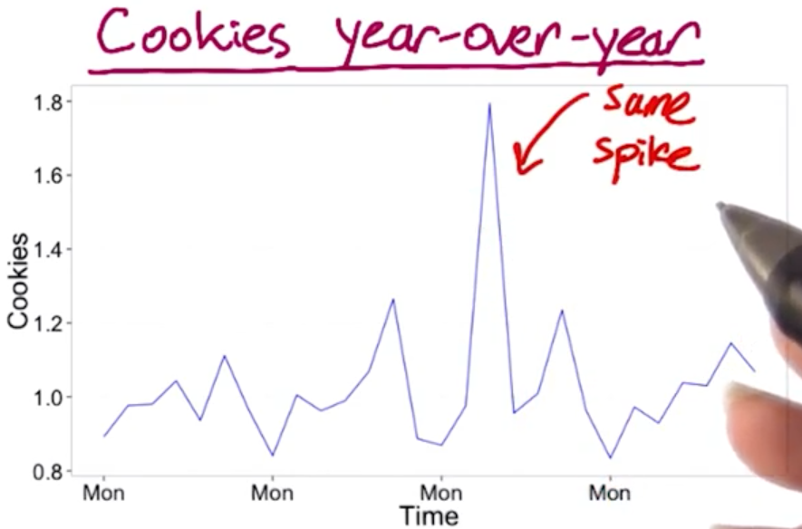 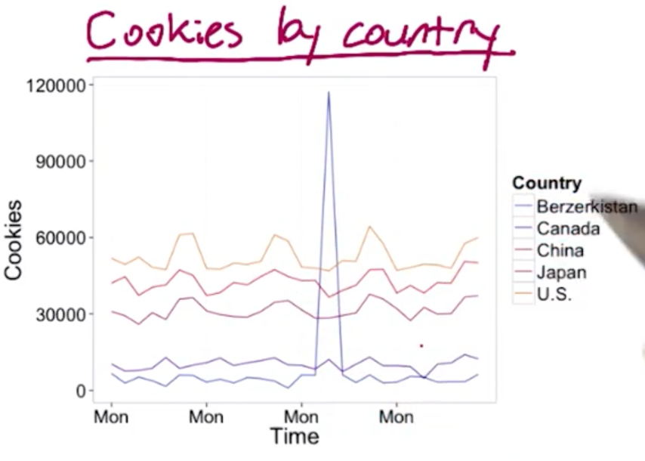
* The spike is coming from only one country. Talk to Engineering team to see if only a few bunches of IP addresses are causing this. It’s likely fraud.

Click-through rate is the ratio of users who click on a specific link to the number of total users who view a page, email, or advertisement. It is commonly used to measure the success of an online advertising campaign for a particular website as well as the effectiveness of email campaigns

The Click-through-probability (CTP) is the probability a given user clicks to get to the next step. Its value is always between 0 and 1. It’s therefore **not** the same as the click-through-rate (CTR) which is the #clicks/#impression.

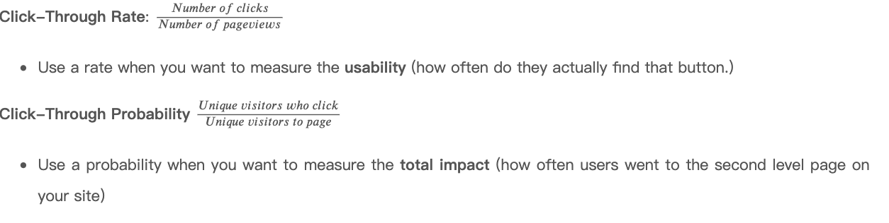

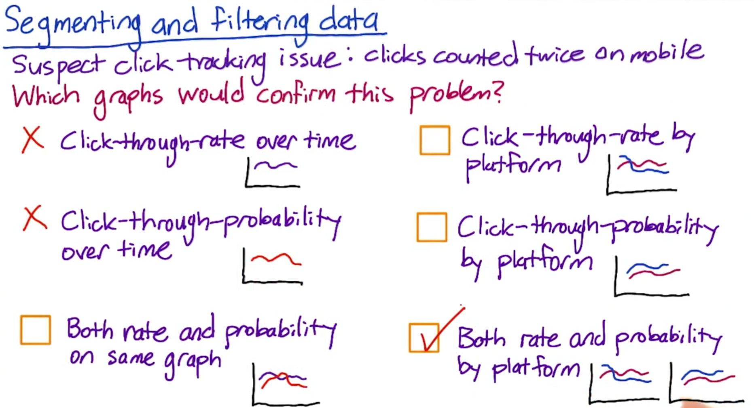

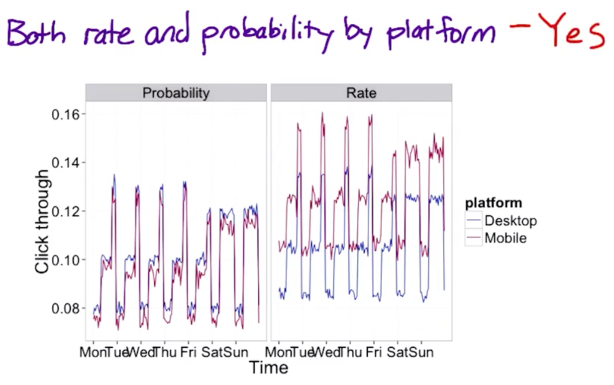

## 16. Summary Metrics

How do you choose between the different options of metrics?

* Establish a few characteristics fr your metric
* First one is sentitivity and robustness
* Second is to characterize what the distribution of your metrics looks like
  + - Most ideal way of doing ths is to do a retrospective analysis
    - And compute a histogram
    - Look at the distribution, is it’s normal, then mean or median make sense.

Four categories that are generally important-

* + - 1. Sums and Counts
      2. Distributional metrics like means, medians, 25th, 75th percentile …
      3. Probabilities and rates
      4. Ratios

Common distributions in online data

Let’s talk about some common distributions that come up when you look at real user data.

For example, let’s measure the rate at which users click on a result on our search page, analogously, we could measure the average stay time on the results page before traveling to a result. In this case, you’d probably see what we call a Poisson distribution, or that the stay times would be exponentially distributed.

Another common distribution of user data is a “power-law,” Zipfian or Pareto distribution. That basically means that the probability of a more extreme value, z, decreases like 1/z (or 1/z^exponent). This distribution also comes up in other rare events such as the frequency of words in a text (the most common word is really really common compared to the next word on the list). These types of heavy-tailed distributions are common in internet data.

Finally, you may have data that is a composition of different distributions - latency often has this characteristic because users on fast internet connection form one group and users on dial-up or cell phone networks form another. Even on mobile phones you may have differences between carriers, or newer cell phones vs. older text-based displays. This forms what is called a mixture distribution that can be hard to detect or characterize well.

The key here is not to necessarily come up with a distribution to match if the answer isn’t clear - that can be helpful - but to choose summary statistics that make the most sense for what you do have. If you have a distribution that is lopsided with a very long tail, choosing the mean probably doesn’t work for you very well - and in the case of something like the Pareto, the mean may be infinite!

Pareto distribution: <https://en.wikipedia.org/wiki/Pareto_distribution>

Poisson Distribution: <https://en.wikipedia.org/wiki/Poisson_distribution>

Exponential distribution: <https://en.wikipedia.org/wiki/Exponential_distribution>

## 17. Summary metrics: Example

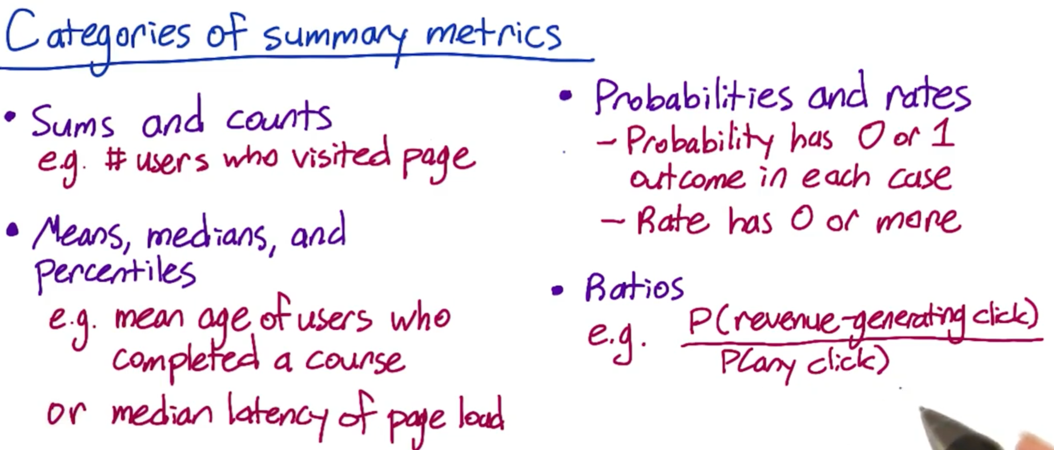

Example of second category of metrics- How long users spend on a particular page of the audacity example.

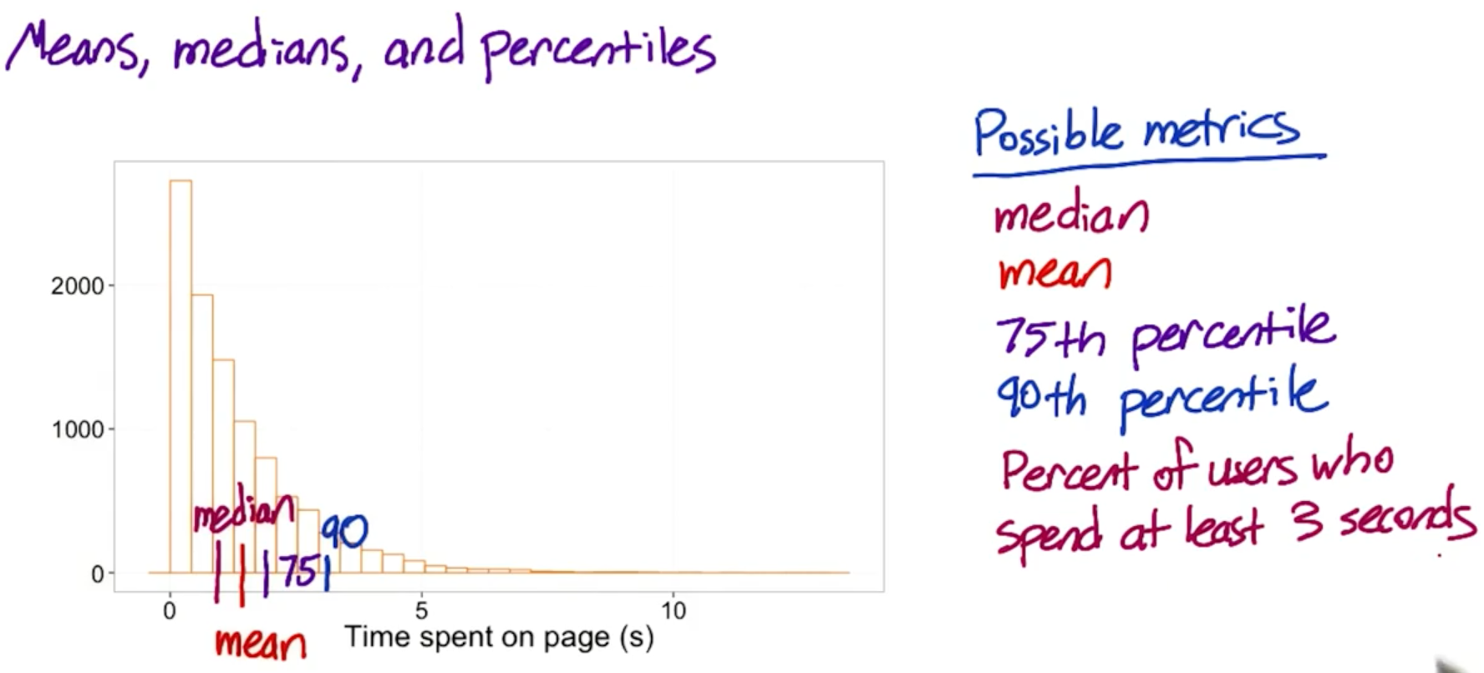

Why probabilities and rates are averages

To see how probabilities are really averages, consider what the probability of a single user would look like - either 1 / 1 if they click, or 0/1 if they don't. Then the probability of all users is the average of these individual probabilities. For example, if you have 5 users, and 3 of them click, the overall probability is (0/1 + 0/1 + 1/1 + 1/1 + 1/1) divided by 5. This is the same as dividing the total number of users who clicked by the number of users, but makes it more clear that the probability is an average.

A rate is the same, except that the numerator for each pageview can be 0 or more, rather than just 0 or 1.

## 18. Sensitivity and Robustness

Sensitivity – The idea for sensitivity is to choose a metric that picks up changes you care about.

Robustness- Metric to be robust against the changes that you don’t care about. So, it doesn’t move a lot when nothing interesting happening.

* Can carry out A vs A experiment to check if they are too sensitive

## 19. Sensitivity and Robustness Example

Example1- Robustness

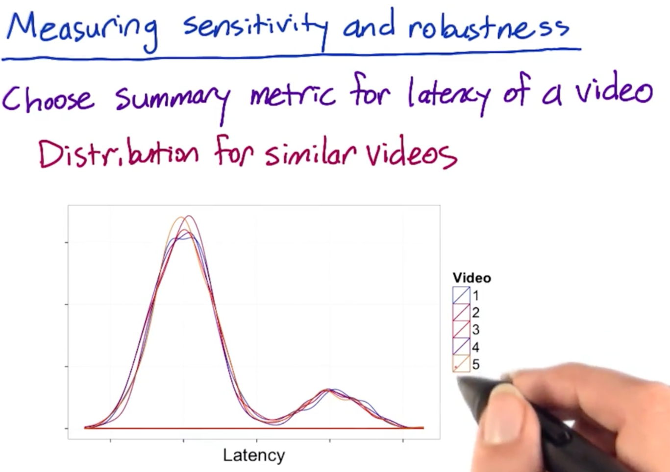

* These are comparable videos; two high peaks denote users with high-speed internet (they have shorter load time) and users with low-speed internet.

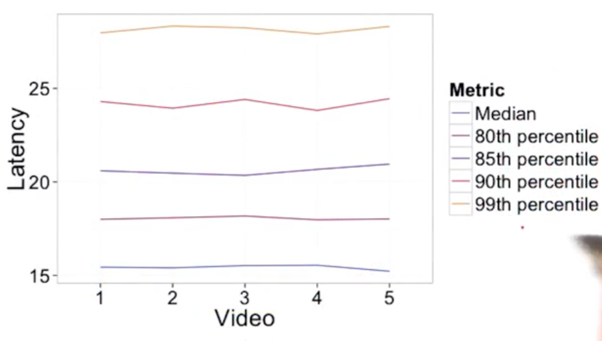

* Since these videos are comparable, there should not have been much difference in load times.
* Not much change in statistics for 80th or 85th percentile, but quite zig-zags for 90th and 95th percentile.
* Hence, 90th and 95th percentile are not robust enough.

Example2- Sensitivity

Now, we are comparing the videos that have change in resolutions and hence their load times vary.

This should impact the latency and if not then our metric is not sensitive enough.

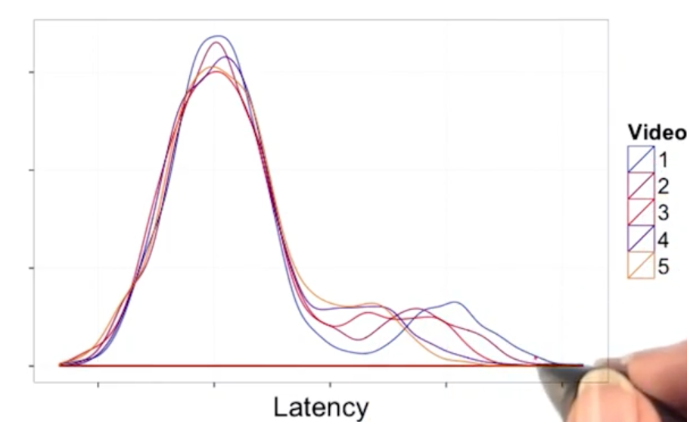 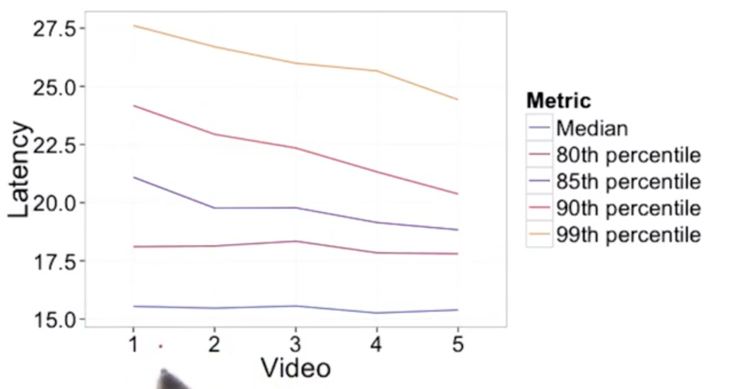

* Median and 80th percentile are not sensitive enough, and not showing a change even though there is a change.
* Hence, 85th percentile is a good metric, which is both robust and sensitive.

## 20. Absolute vs Relative difference

* Now we have to decide how do we compute the comparison.
* We have a value for your experiment, have a value for your control. But, now, have to decide how to compare the difference between the experiment and the control.
* Simplest way is to take absolute difference
* But, if you are running a lot of experiments, then computing a relative change (percent change) is better.
* Advantage of choosing percent change is to choose one practical significance boundary to get the stability over time.
* Example- comparing a metric in June (low shopping period) vs December can be computed within the same boundary.
* Disadvantage is that relative change or ratios are not always as well behaved as absolute difference.

**Absolute vs. relative difference**

Suppose you run an experiment where you measure the number of visits to your homepage, and you measure 5000 visits in the control and 7000 in the experiment. Then the absolute difference is the result of subtracting one from the other, that is, 2000. The relative difference is the absolute difference divided by the control metric, that is, 40%.

**Relative differences in probabilities**

For probability metrics, people often use percentage points to refer to absolute differences and percentages to refer to relative differences. For example, if your control click-through-probability were 5%, and your experiment click-through-probability were 7%, the absolute difference would be 2 percentage points, and the relative difference would be 40 percent. However, sometimes people will refer to the absolute difference as a 2 percent change, so if someone gives you a percentage, it's important to clarify whether they mean a relative or absolute difference!

## 21. Variability

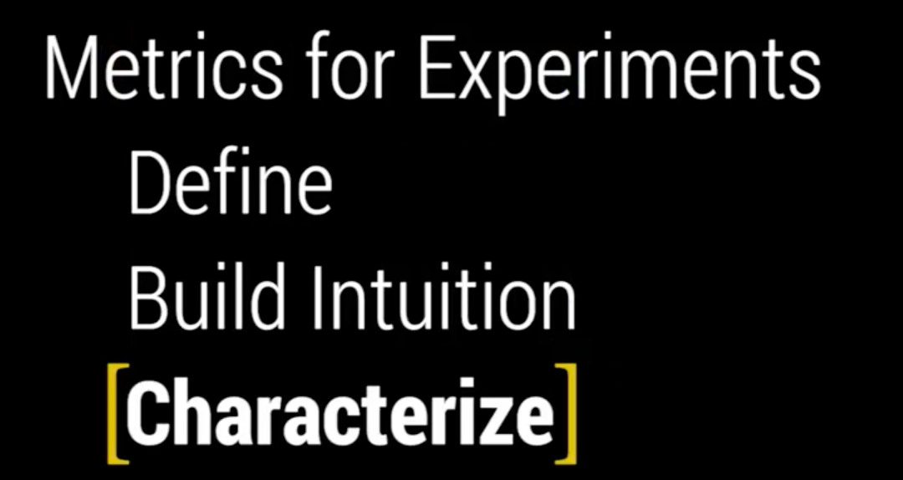

Variability is the next thing under Characterize bucket.

## 22. Variability Example

Example of calculating variability for a binomial distribution-

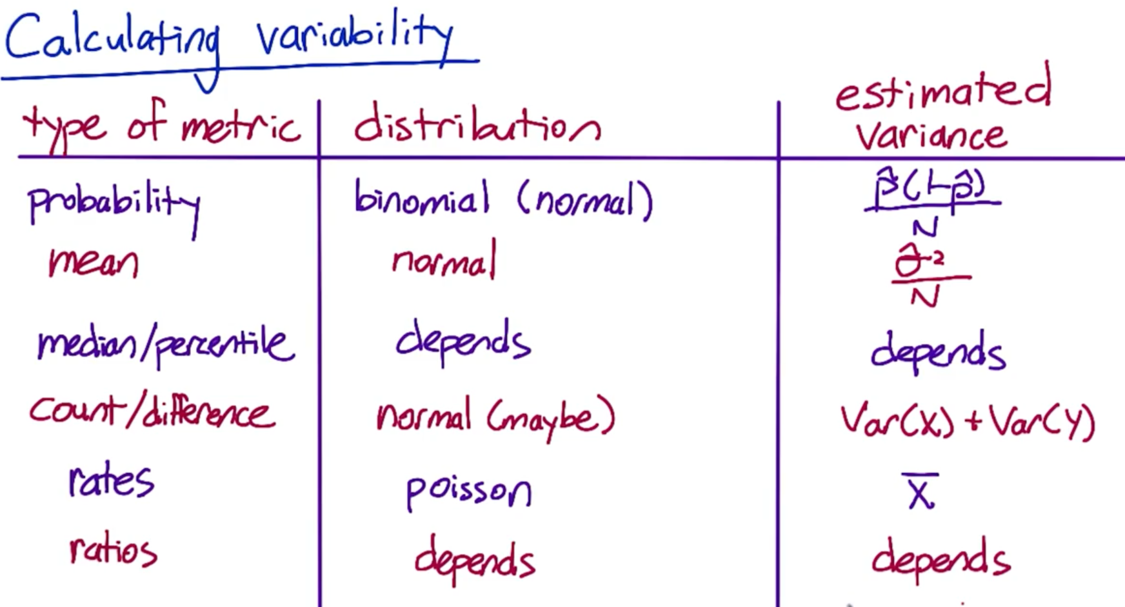

* Median and ratios are difficult metrics to use as it is dependent on the underlying distribution, and it is difficult to calculate the variance analytically.

**Difference between Poisson variables**

The difference in two Poisson means is not described by a simple distribution the way the difference in two Binomial probabilities is. If your sample size becomes very large, and your rate is not infinitesimally small, sometimes you can use a Normal confidence interval by the law of large numbers. But usually you have to do something a little more complex. For some options, see here (for a simple summary), here section 9.5 (for a full summary) and here (for one free online calculation). If you have access to some statistical software such as R (free distribution), this is a good time to use it because most programs will have an implementation of these tests you can use.

If you aren’t confident in the Poisson assumption, or if you just want something more practical - and frankly, more common in engineering, see the Empirical Variability section of this lesson, which starts here.

Quiz data

Here is the quiz data for you to copy and paste: [87029, 113407, 84843, 104994, 99327, 92052, 60684]

If you prefer, you can also make a copy of this spreadsheet. To do this, sign into Google Drive, then click "File > Make a Copy" on the spreadsheet.

Using Google spreadsheets

If you'd like to use Google spreadsheets to calculate the standard deviation, but you haven't used it for something like this before, this tutorial may be helpful.

## 23. Non-parametric Answers

* Non-parametric methods - You have a way to analyze the data without making an assumption about what the distribution is.
* These can be noisier and computationally intensive, but can also be very useful.
* These methods can be used to evaluate metrics that are difficult to calculate analytically

Example – Sign test

## 24. Empirical Variability

* For more complex metrics, you might need to calculate your metric empirically instead of courting analytically.
* For more complicated metrics, the underlying distribution could be very weird and so you might want to shift to an empirical estimate.
* You can use A vs A test for this purpose.

In A vs A experiment, both control and experiment sets are the same, there’s no change in what the users are seeing. So, any differences that you measure are due to the underlying variability, may be from the system, user population…

* You can either run many A vs A tests
* Or you can run one big A vs A test and then use bootstrap method to dice and slice

## 25. Empirical Variability: Sanity Checking

Google sheet link: <https://docs.google.com/spreadsheets/d/17wWNY2jkDlG9BDMYQq2l-ku_8HGajXuF2Zvy__dBEL4/edit#gid=0>

Compare empirical results and analytical results

* Empirical results using A/A tests on click-thru-probability metrics
* Analytical results using mean, std_dev were calculated in Chapter-1

Three things you can do using A/A tests-

* 1. Compare results to what you expect from analytical results (sanity check)
  2. If you are willing to make an assumption about distribution of your metric, but weren’t able to estimate the variance analytically, you can estimate variance and calculate confidence using A/A
  3. If you don’t want to make any assumption about your data, you can directly estimate CI from the results of A/A tests

Compare results to what you expect-

* Let’s say we ran 20 experiments each on 0.5% of traffic
* Then ran 20 more experiments each on 1% of traffic
* Then 10 more each on 5% traffic
* All of the above 3 are A/A tests with no difference between the two groups.

**Measure the first point -**

How many experiments will show a statistically significant difference at the 95% level?

* Even though there was no significant difference bwtween the two groups, even than 95% CI means that the true value of zero (0 difference) will only be captured 95% of the time.
* That means, out of 20 experiments, we expect to see one significant difference on average.
* Also, we expect the results of multiple runs on the difference of the two groups to follow a normal distribution. From the result, we do see normal distribution for small group. For medium and large set, we do not have enough A/A experiments, and probably that’s causing it to not have normal chart.
* The distributions are getting tighter as sample size increases (0.5% to 5%)

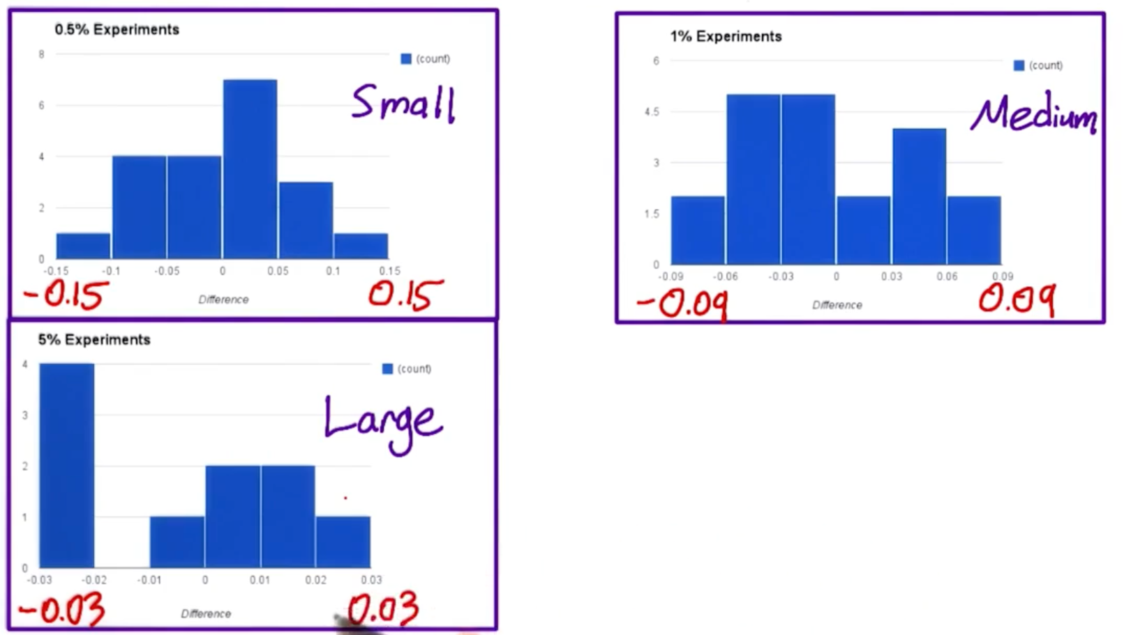

## 26. Empirical CI

**Measure the second point – Estimate variance and calculate confidence interval.**

* We want to get the variance empirically, if we weren’t able to calculate it analytically.
* Calculate std dev from our A/A experiments
* Calculate margin of error- empirically there would be only one margin of error across all experiments.
* Analytically, we use pooled standard error to calculate the margin of error, which was different for each experiment.
* In the results, pooled standard varies, but always close to 0.059.

**Measure the third point – Direclty estimate Confidence Interval.**

* If your metric doesn’t show a normal distribution, then you can directly estimate a CI from the results of you A/A tests

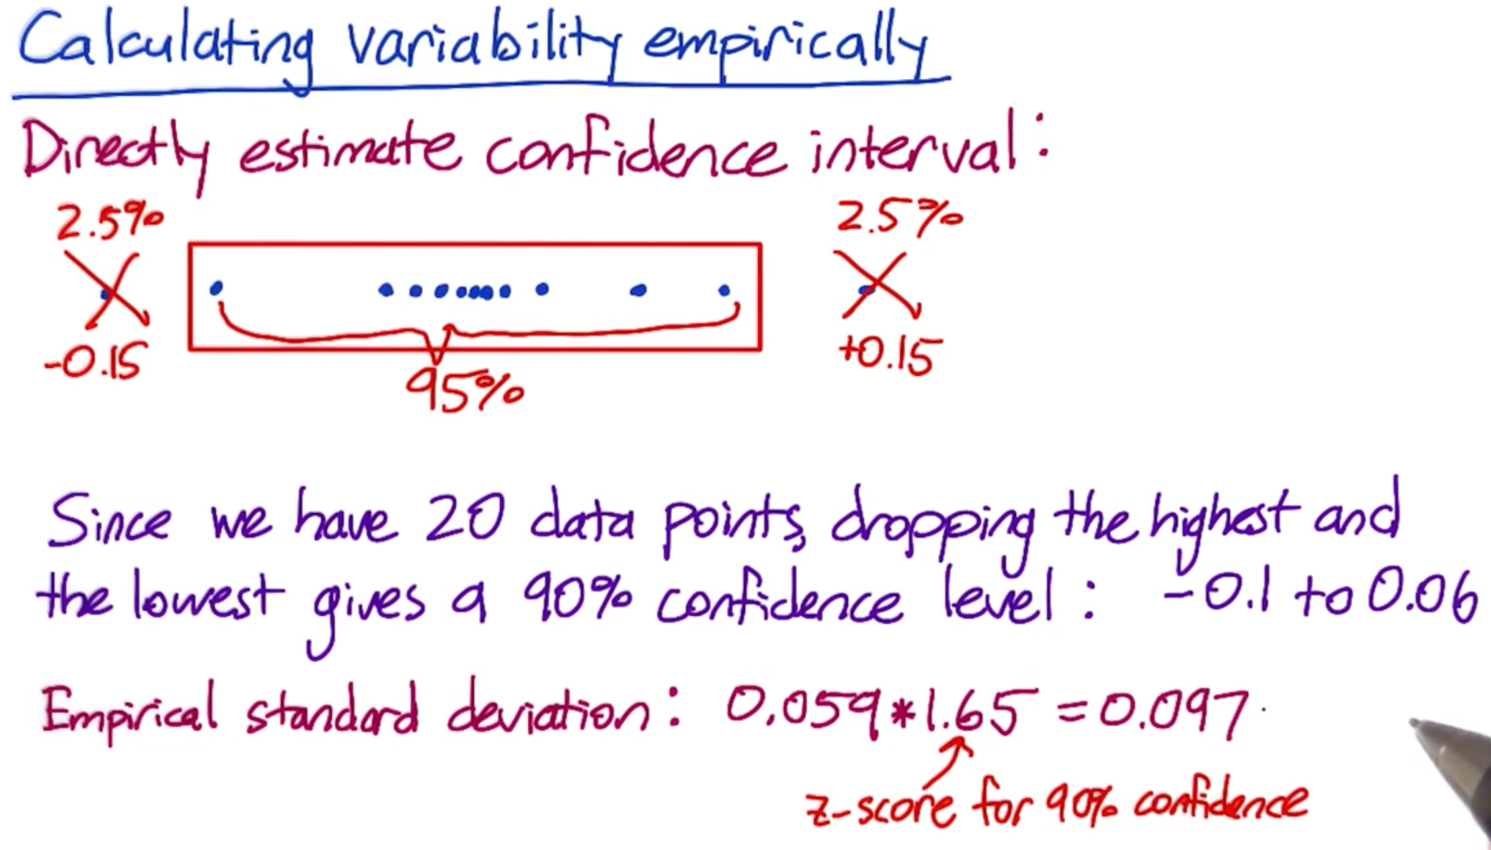

* The two methods give a sort of close answer, but not that close. The main reason is that we have only 20 data points. You need to run more A/A tests to actually trust this CI, unless each test was run for a pretty long time (bootstrap method).

## 27. Empirical Variability: Bootstrapping

* If you do not want to run many A/A tests, then you can run one experiment and then use it to estimate the variability of your metric using something called the Bootstrap method.
* The idea of bootrapping is that you run one experiment, then you take a random sample of those data points from each side of the experiment, and calculate the click-through-probability based on that random sample as if it were a full experimental group.
* Then you record the difference in CTR and use that as a simulated experiment.
* You then repeat this process over and over, recording the results. And you can use the results as if you had run multiple experiments.

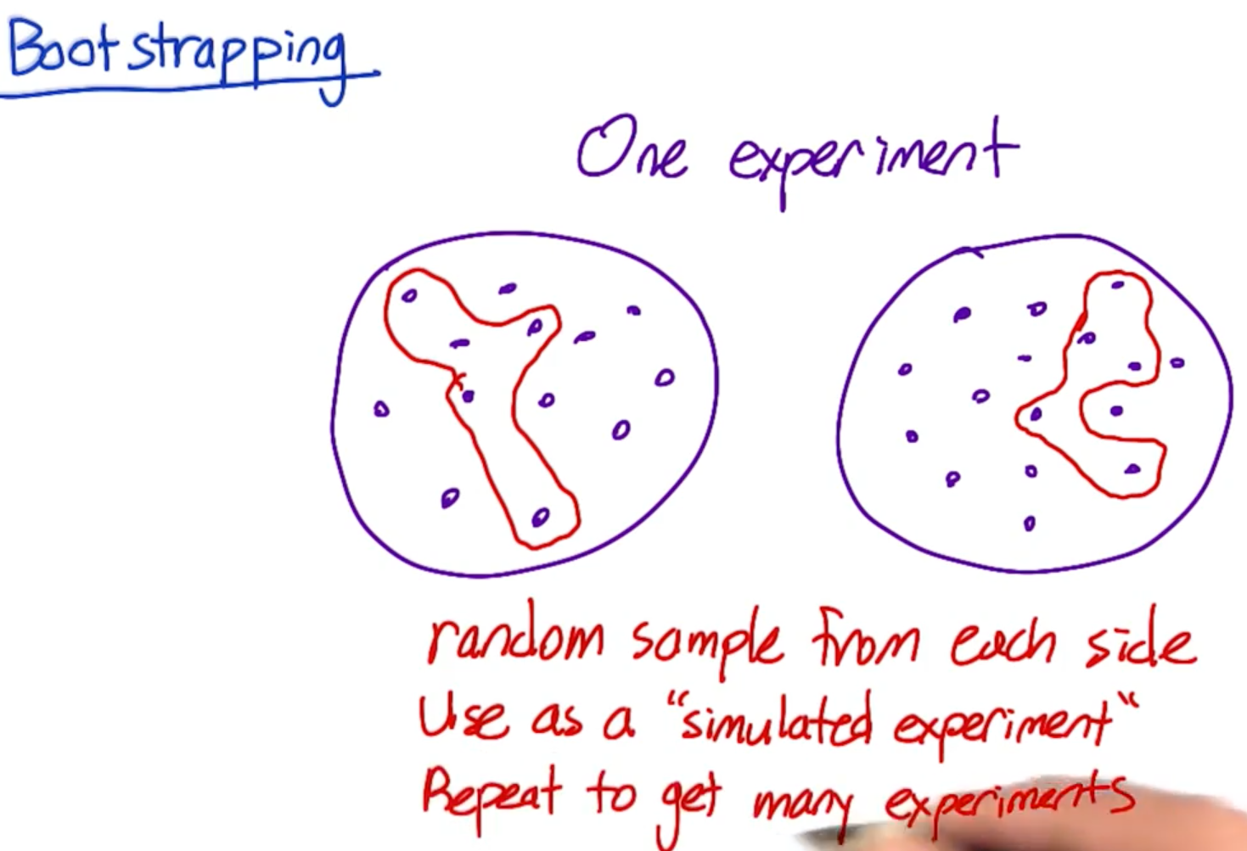

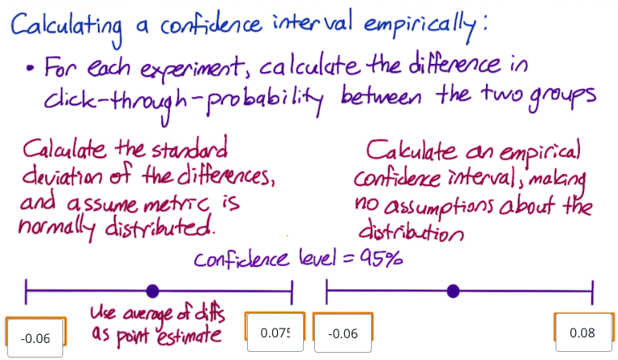

* When collecting a random sample for bootstrapping, it's important to sample with replacement - meaning it's possible to choose the same event twice within a group

## 28. Variability Summary

* Different metrics have different variabilitity
* In order to understand the variaiblitiy, we ned to understand the distribution of the underlying data
* Author at Google spent majority of time in coming up with, validating and choosing metrics to be used in evaluation.
* Especially validating metrics
* Also, you have to work with you engineers to understand the nuances about how data is actually being captured.